………………………….LAB 04……………………….
Headers and footers, Page numbers, Pictures and text wrapping, Formatting pictures, Shapes, Text boxes.

Tasks:
- Under the Shape Effects drop-down menu, add a Round Bevel.
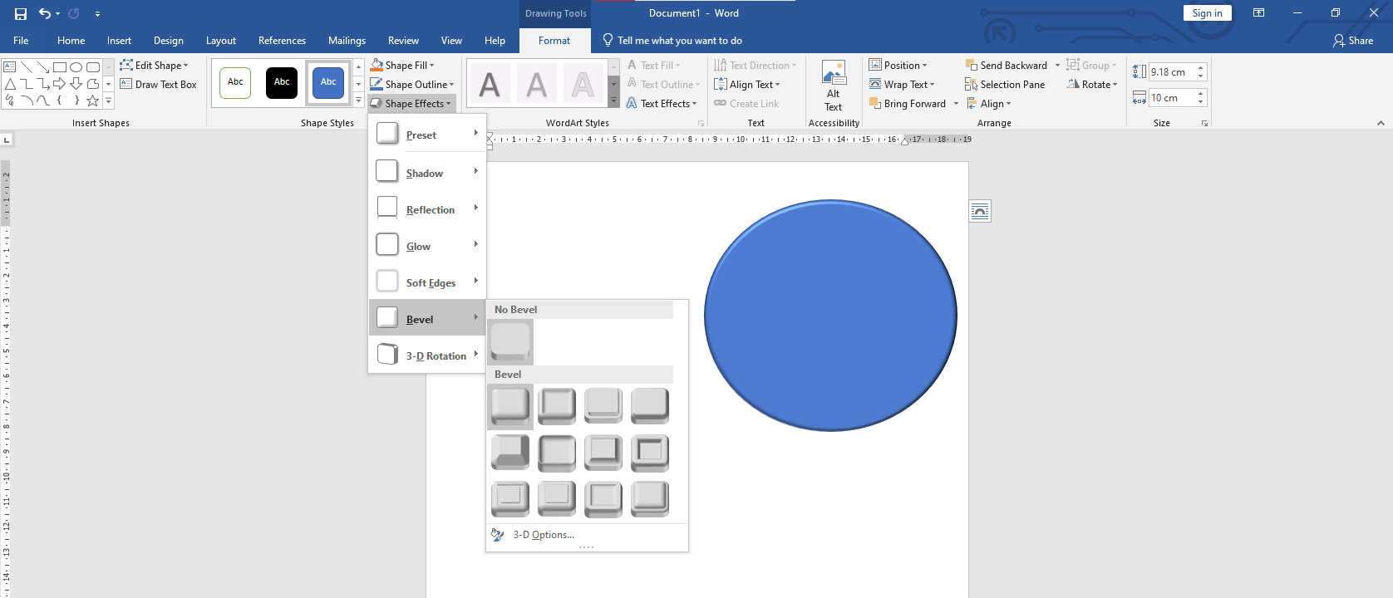
- Change the shape style to your choice of a Gold style. Hint: Style names appear
when you hover over them. Make sure the style name has the word Gold in it

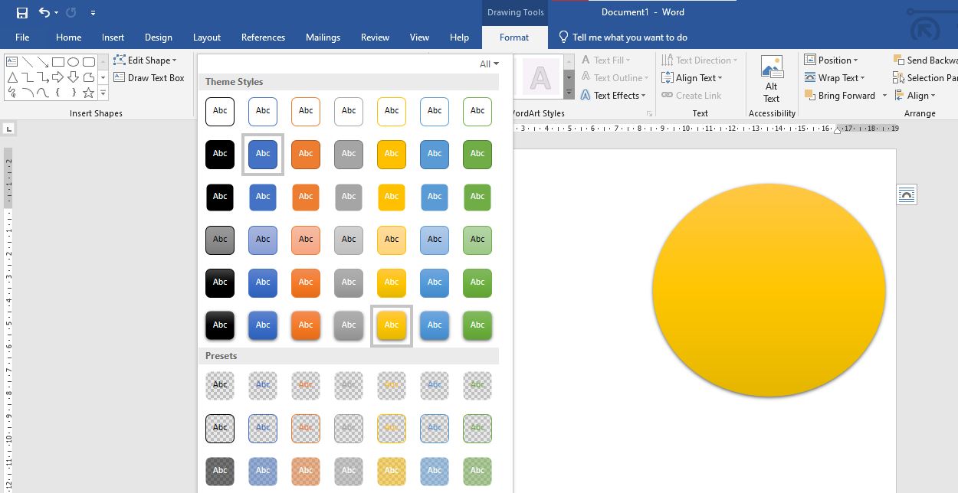

- In the Format tab, change the style to Simple Frame, White.

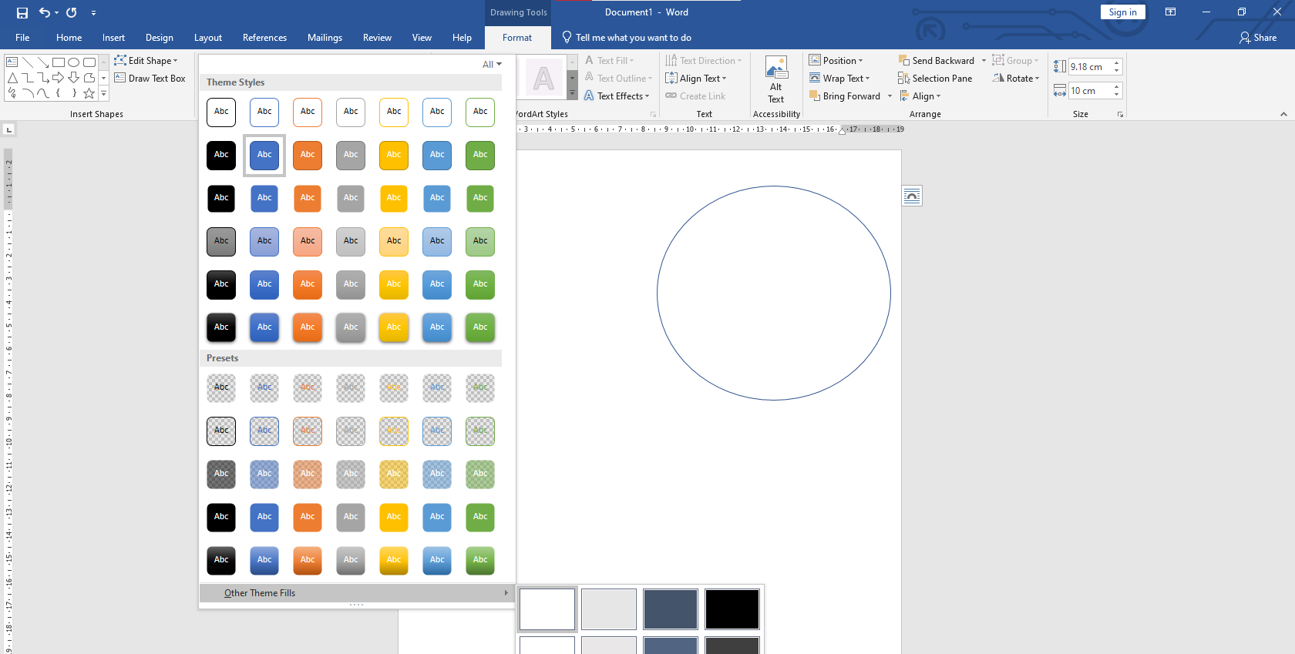
- Text Wrapping Activity: Create a Mini-Poster
Choose a Topic: Choose a fun topic, like favorite animal, sport, or place to visit.

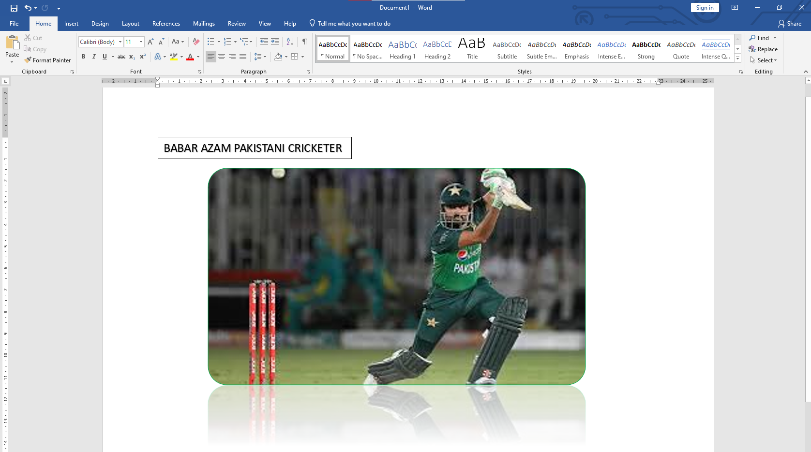

- Insert an Image:Search for a suitable image online (or use an image provided by the teacher) and insert it into a Word document.
Resize the image to a medium size so it fits well with text.
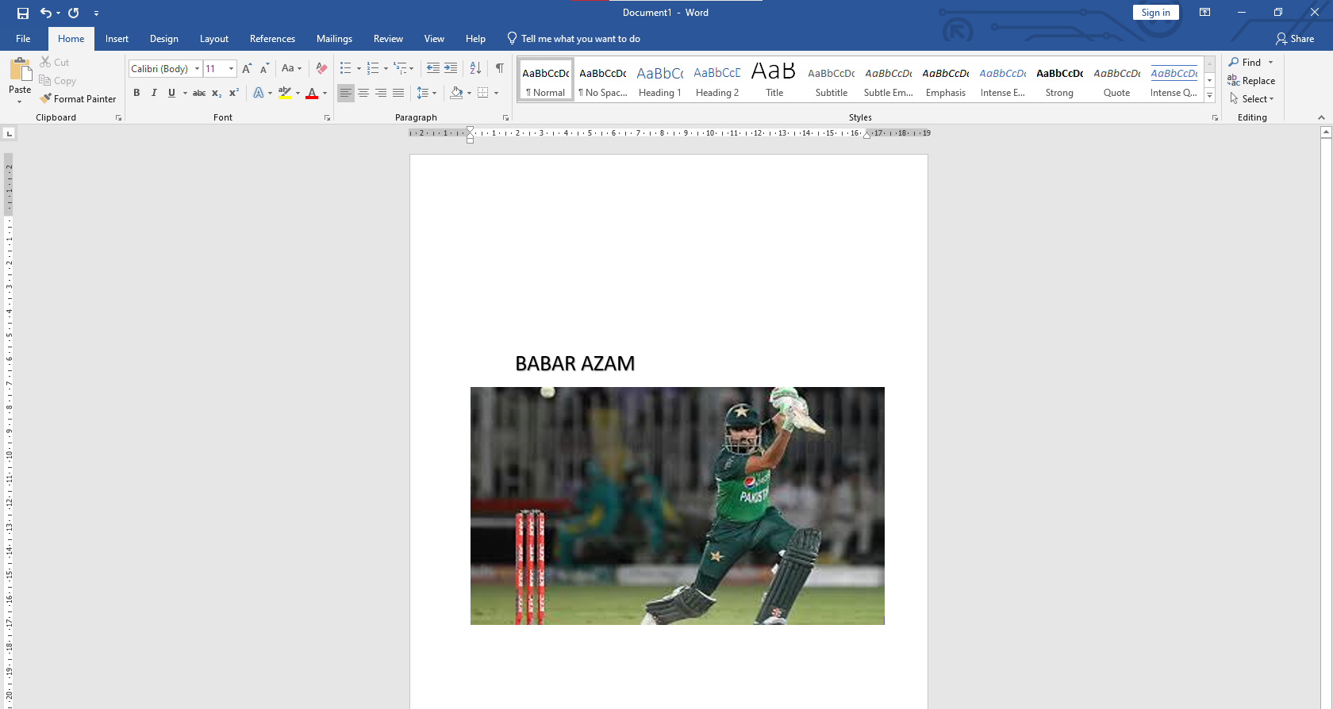
- Experiment with Text Wrapping:
Click on the image, go to "Format" > "Wrap Text", and try each of the following text wrapping options:
In Line with Text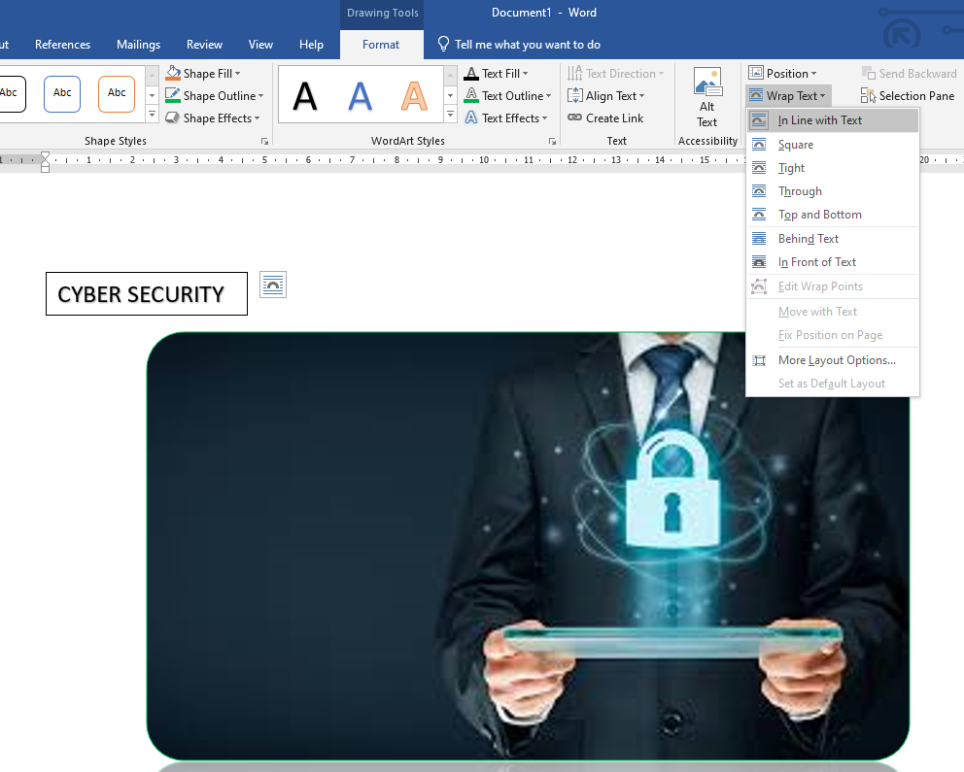
Tight

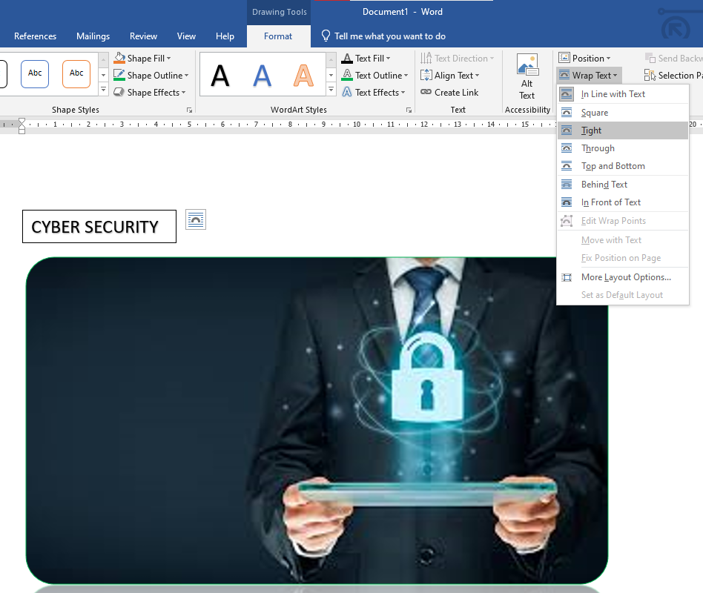

Top and Bottom
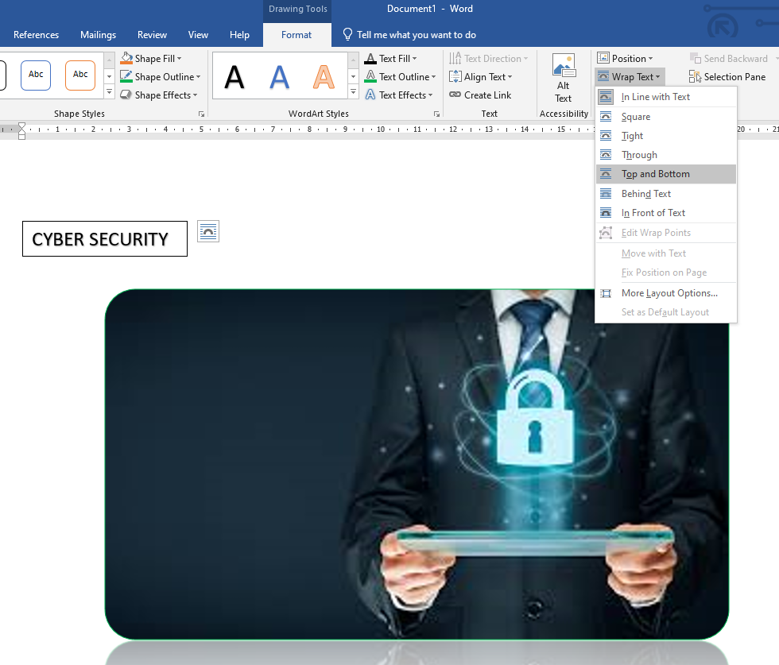

Behind Text
